Step 1: Go on Netsuite and type in the customer number: C13375 EBAY

Step 2: Create a Sales Order
(Hover over the paper icon with a “+” symbol)
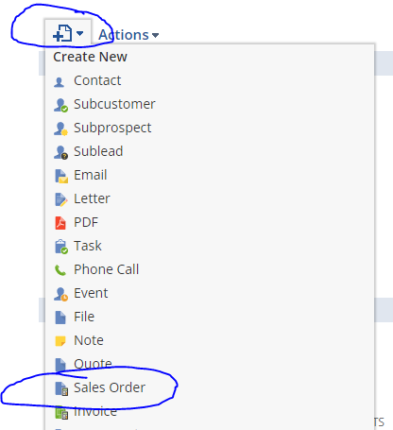
(click “Sales Order”)
Step 3: Pull up the order on ebay and Click the order number
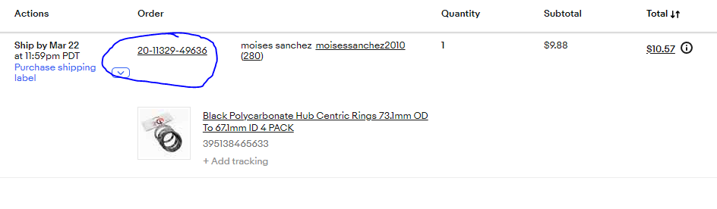

Step 4: Return to Netsuite and add the following to the fields:
PO# : CUSTOMERS NAME
MEMO: ORDER NUMBER FROM EBAY
SO STATUS: READY
SALES TYPE: EBAY ORDER
DELIVERY TYPE: SHIPPING (FEDEX,UPS,ADL., ETC)
LOCATION: TAMPA

Step 5: Enter in Shipping info
Click: “SHIP TO SELECT”
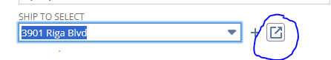
- Select Edit Button:
- Enter in Customer Info found on the ebay order
- Click Save

Step 6: Enter in product information
- Go to the Ebay Order
- Scroll down to “Item” and Click the Underlined text with the items they purchased
- Scroll down on the item page to “Item Specifics”
- Copy the “Manufacturer Part Number”
- Go to Netsuite Sales Order
- Scroll down and paste the “Manufacturer Part Number” in the “type then tab”
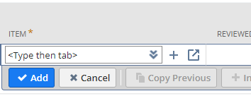

- Change the Amount on the Sales Order to the Ebay order “Item Subtotal” found in the ebay order
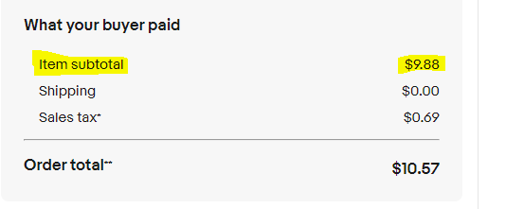
- A pop up will display and just click “Ok”
- Add another Line item named “Ebay Fee”
- Add the fee amount that can be found on the ebay order page labeled under “Transaction Fees”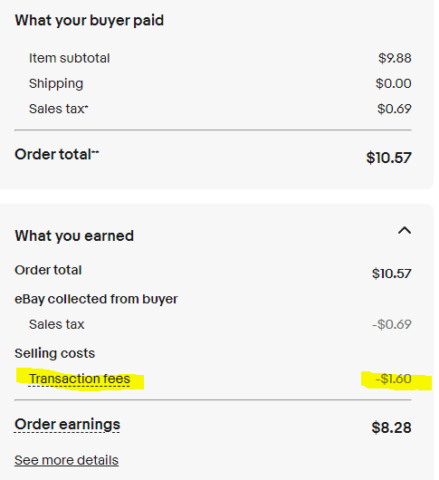
- Add another line item on the sales order in netsuite called “Freight” then click add.
- Add another line item on the sales order in netsuite called “Freight - Discount” and add -40 in the amount field, then click add.
- Scroll up on the sales order and make sure the summary total matches the Ebay order “order earnings”

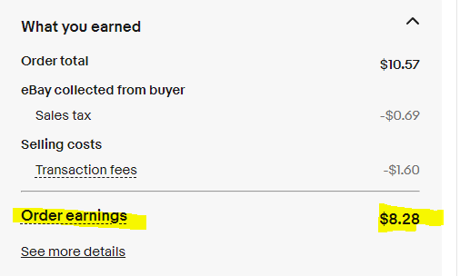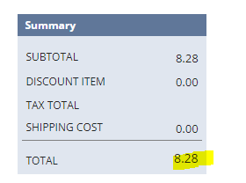

Step 6: Save the Sales Order and copy the SO Number once the page loaded
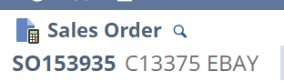

Step 7:
Email ew.shipping@ewwfl.com,
CC: jacqueline@ewwfl.com(cap/other shipper)
- In the subject line add the Sales Order Number
- In the text field request this SO to be pulled and have them email you the Tracking information

Step 8: Enter in the Tracking information in the Ebay Order
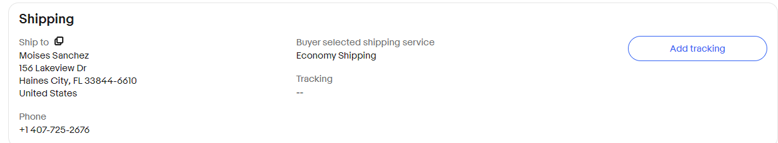

eBay developer account access:

https://developer.ebay.com/
dev.ebay@ewwfl.com
73#+2W=%Rl4!1$amtDI

Netsuite access:
https://4520456-sb1.app.netsuite.com/app/common/entity/employeelist.nl?scrollid=31230&whence=T&cmid=1733936366952_16964

Pass: Elite@987123 uname: shreyas@ewwfl.com

